TCS3351 Cryptography and Data Security
Tutorial 5 Questions
Modern Symmetric Ciphers-II (Advanced Encryption Standard (AES))

- Answer the following questions with respect to Advanced Encryption Standard (AES).

  - List the block size, key size, number of rounds, number of round keys, and number of transformations for the three AES versions.
  - Define a state in AES. How many states are there in each version of AES?
  - If a and b are two bytes, show that
SubBytes (a⊕b) ≠ SubBytes (a) ⊕ SubBytes (b)
Use a = (35)₁₆ and b = (46)₁₆ as an example.

- With respect to Advance Encryption Standard, answer the following:
Given the plaintext
(00 01 02 03 04 05 06 07 08 09 0A 0B 0C 0D 0E 0F)_{H}
and the key
(01 01 01 01 01 01 01 01 01 01 01 01 01 01 01 01)_{H}

- Show the original contents of State, displayed as a 4×4 matrix.
- Show the value of State after initial AddRoundKey.
- Show the value of State after SubBytes.
- Show the value of State after ShiftRows.
- Show the value of State after MixColumns.

Note:

- SubByte Transformation Table
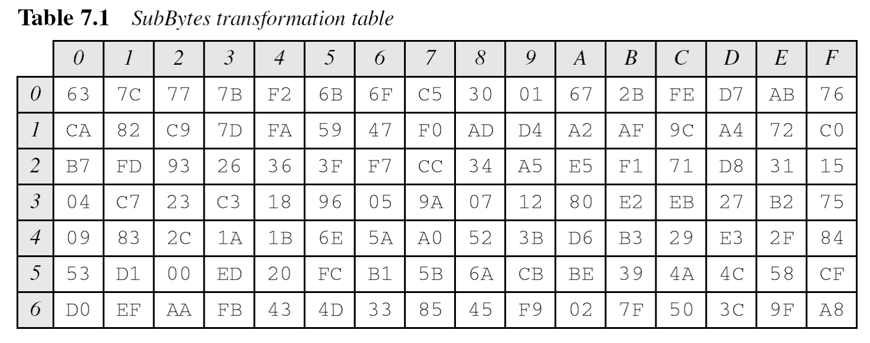
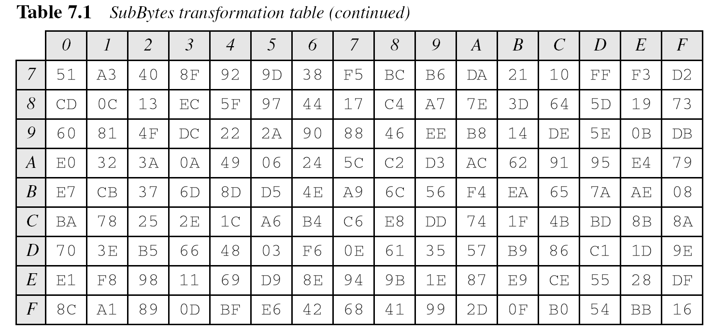

(ii) Constant matrices used by MixColumns and InvMixColumns

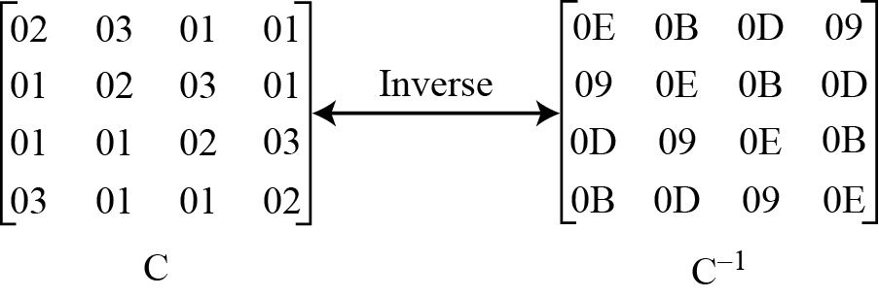

- With reference to Advanced Encryption Standard (AES-128) key expansion algorithm, identify the first 3 subround keys.

Given Key:
(0F 15 71 C9 47 D9 E8 59 0C B7 AD D6 AF 7F 67 98)_{H}

References:

- Behrouz A. Forouzan, "Cryptography and Network Security", First Edition, McGraw-Hill, 2008.

- William Stallings, “Cryptography and Network Security – Principles and Practice”, Seventh Edition, Prentice Hall, 2016.

